Project Design Phase
Problem – Solution Fit Template

Date | 29 September 2026
Team ID | SWTID-2026-5660
Project Name | Script-Controlled ACL – Restrict Record Access Based on Field Value
Maximum Marks | 2 Marks

Problem – Solution Fit Template:
The Problem-Solution Fit simply means that you have found a problem with your customer and that the solution you have realized for it actually solves the customer’s problem. It helps entrepreneurs, marketers and corporate innovators identify behavioral patterns and recognize what would work and why
Purpose:
- Solve complex problems in a way that fits the state of your customers.
- Succeed faster and increase your solution adoption by tapping into existing mediums and channels of behavior.
- Sharpen your communication and marketing strategy with the right triggers and messaging.
- Increase touch-points with your company by finding the right problem-behavior fit and building trust by solving frequent annoyances, or urgent or costly problems.
- Understand the existing situation in order to improve it for your target group.

Template:
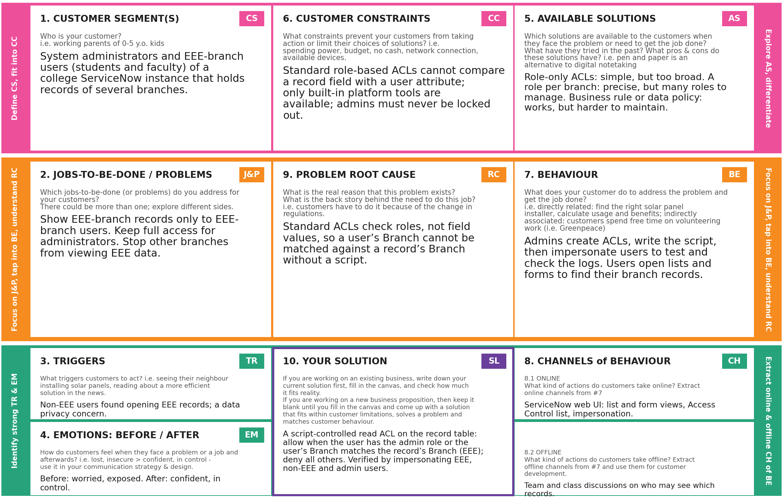
References:
- https://www.ideahackers.network/problem-solution-fit-canvas/
- https://medium.com/@epicantus/problem-solution-fit-canvas-aa3dd59cb4fe

Project Design Phase
Proposed Solution Template

Date | 29 September 2026
Team ID | SWTID-2026-5660
Project Name | Script-Controlled ACL – Restrict Record Access Based on Field Value
Maximum Marks | 2 Marks

Proposed Solution Template:
Project team shall fill the following information in the proposed solution template.
S.No. | Parameter | Description
 | Problem Statement (Problem to be solved) | In a college ServiceNow instance, records of several branches are stored together, and standard role-based ACLs cannot compare a record’s Branch value with the user’s own Branch. As a result, users from other branches can view records that belong only to the EEE branch.  The problem to be solved is to restrict access so that only EEE-branch users can view records whose Branch field is EEE, while administrators retain full access.
 | Idea / Solution description | Implement a script-controlled Access Control List (ACL) on the read operation of the record table. The ACL script allows access when the logged-in user has the admin role, or when the user’s Branch is EEE and the record’s Branch field is EEE. Every other request is denied.  The ACL is verified by impersonating an EEE user, a non-EEE user and an administrator.
 | Novelty / Uniqueness | Instead of creating a separate role or table for each branch, one script-based ACL decides access at run time by comparing the record’s field value with the user’s attribute. This keeps the setup simple, needs no extra roles, and protects every record on the server side.
 | Social Impact / Customer Satisfaction | Protects the privacy of branch data and gives administrators confidence that only authorised users can view EEE records. EEE users reach the records they need without extra steps, and administrators keep full access, so the work of both groups is not disrupted.
 | Business Model (Revenue Model) | This is a lab project with no direct revenue. It can be reused as a standard ACL pattern, or offered as part of a ServiceNow access-management service for institutions, where the value comes from lower data-exposure risk and less administration effort.
 | Scalability of the Solution | The same script works for any number of records and users. Other branches (for example CSE or ECE) can be supported by changing the Branch condition in the script instead of creating new ACLs, and the logic can be reused on other tables that have a Branch field.

Project Design Phase
Solution Architecture

Date | 29 September 2026
Team ID | SWTID-2026-5660
Project Name | Script-Controlled ACL – Restrict Record Access Based on Field Value
Maximum Marks | 4 Marks

Solution Architecture:
Solution architecture is a complex process – with many sub-processes – that bridges the gap between business problems and technology solutions. Its goals are to:
- Find the best tech solution to solve existing business problems.
- Describe the structure, characteristics, behavior, and other aspects of the software to project stakeholders.
- Define features, development phases, and solution requirements.
- Provide specifications according to which the solution is defined, managed, and delivered.

Example - Solution Architecture Diagram:

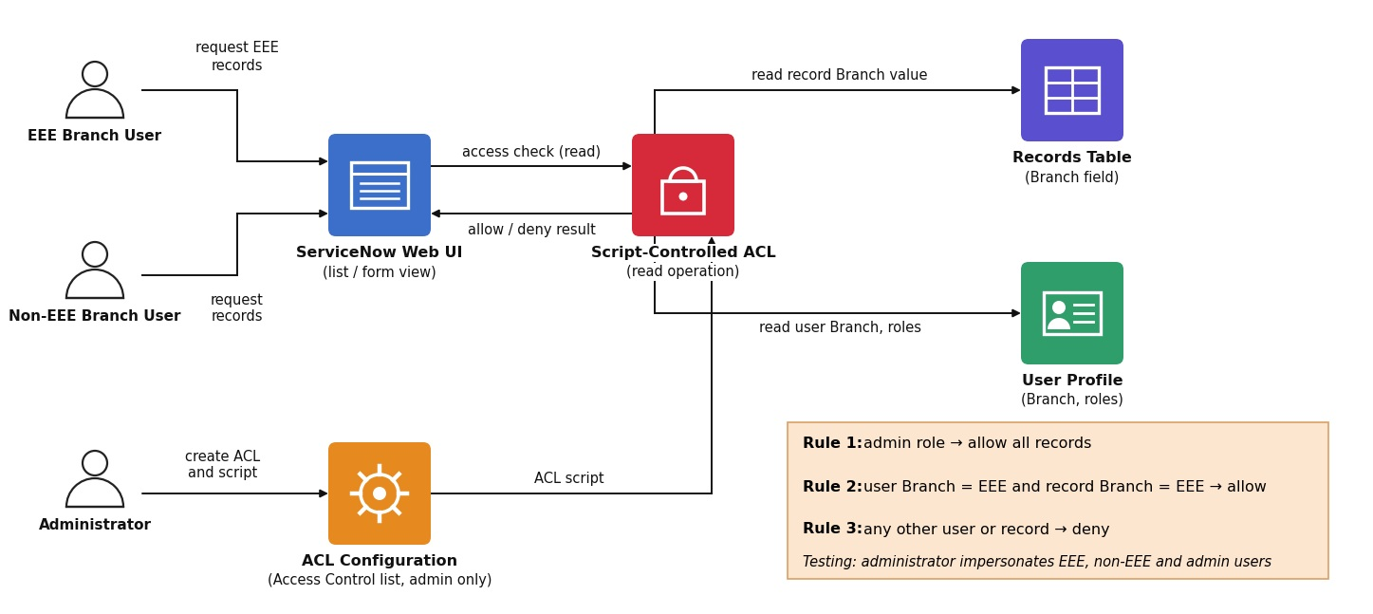
Figure 1: Architecture and data flow of the script-controlled ACL
Reference: https://aws.amazon.com/blogs/industries/voice-applications-in-clinical-research-powered-by-ai-on-aws-part-1-architecture-and-design-considerations/

